**Raport Optică – Spectroscopul**

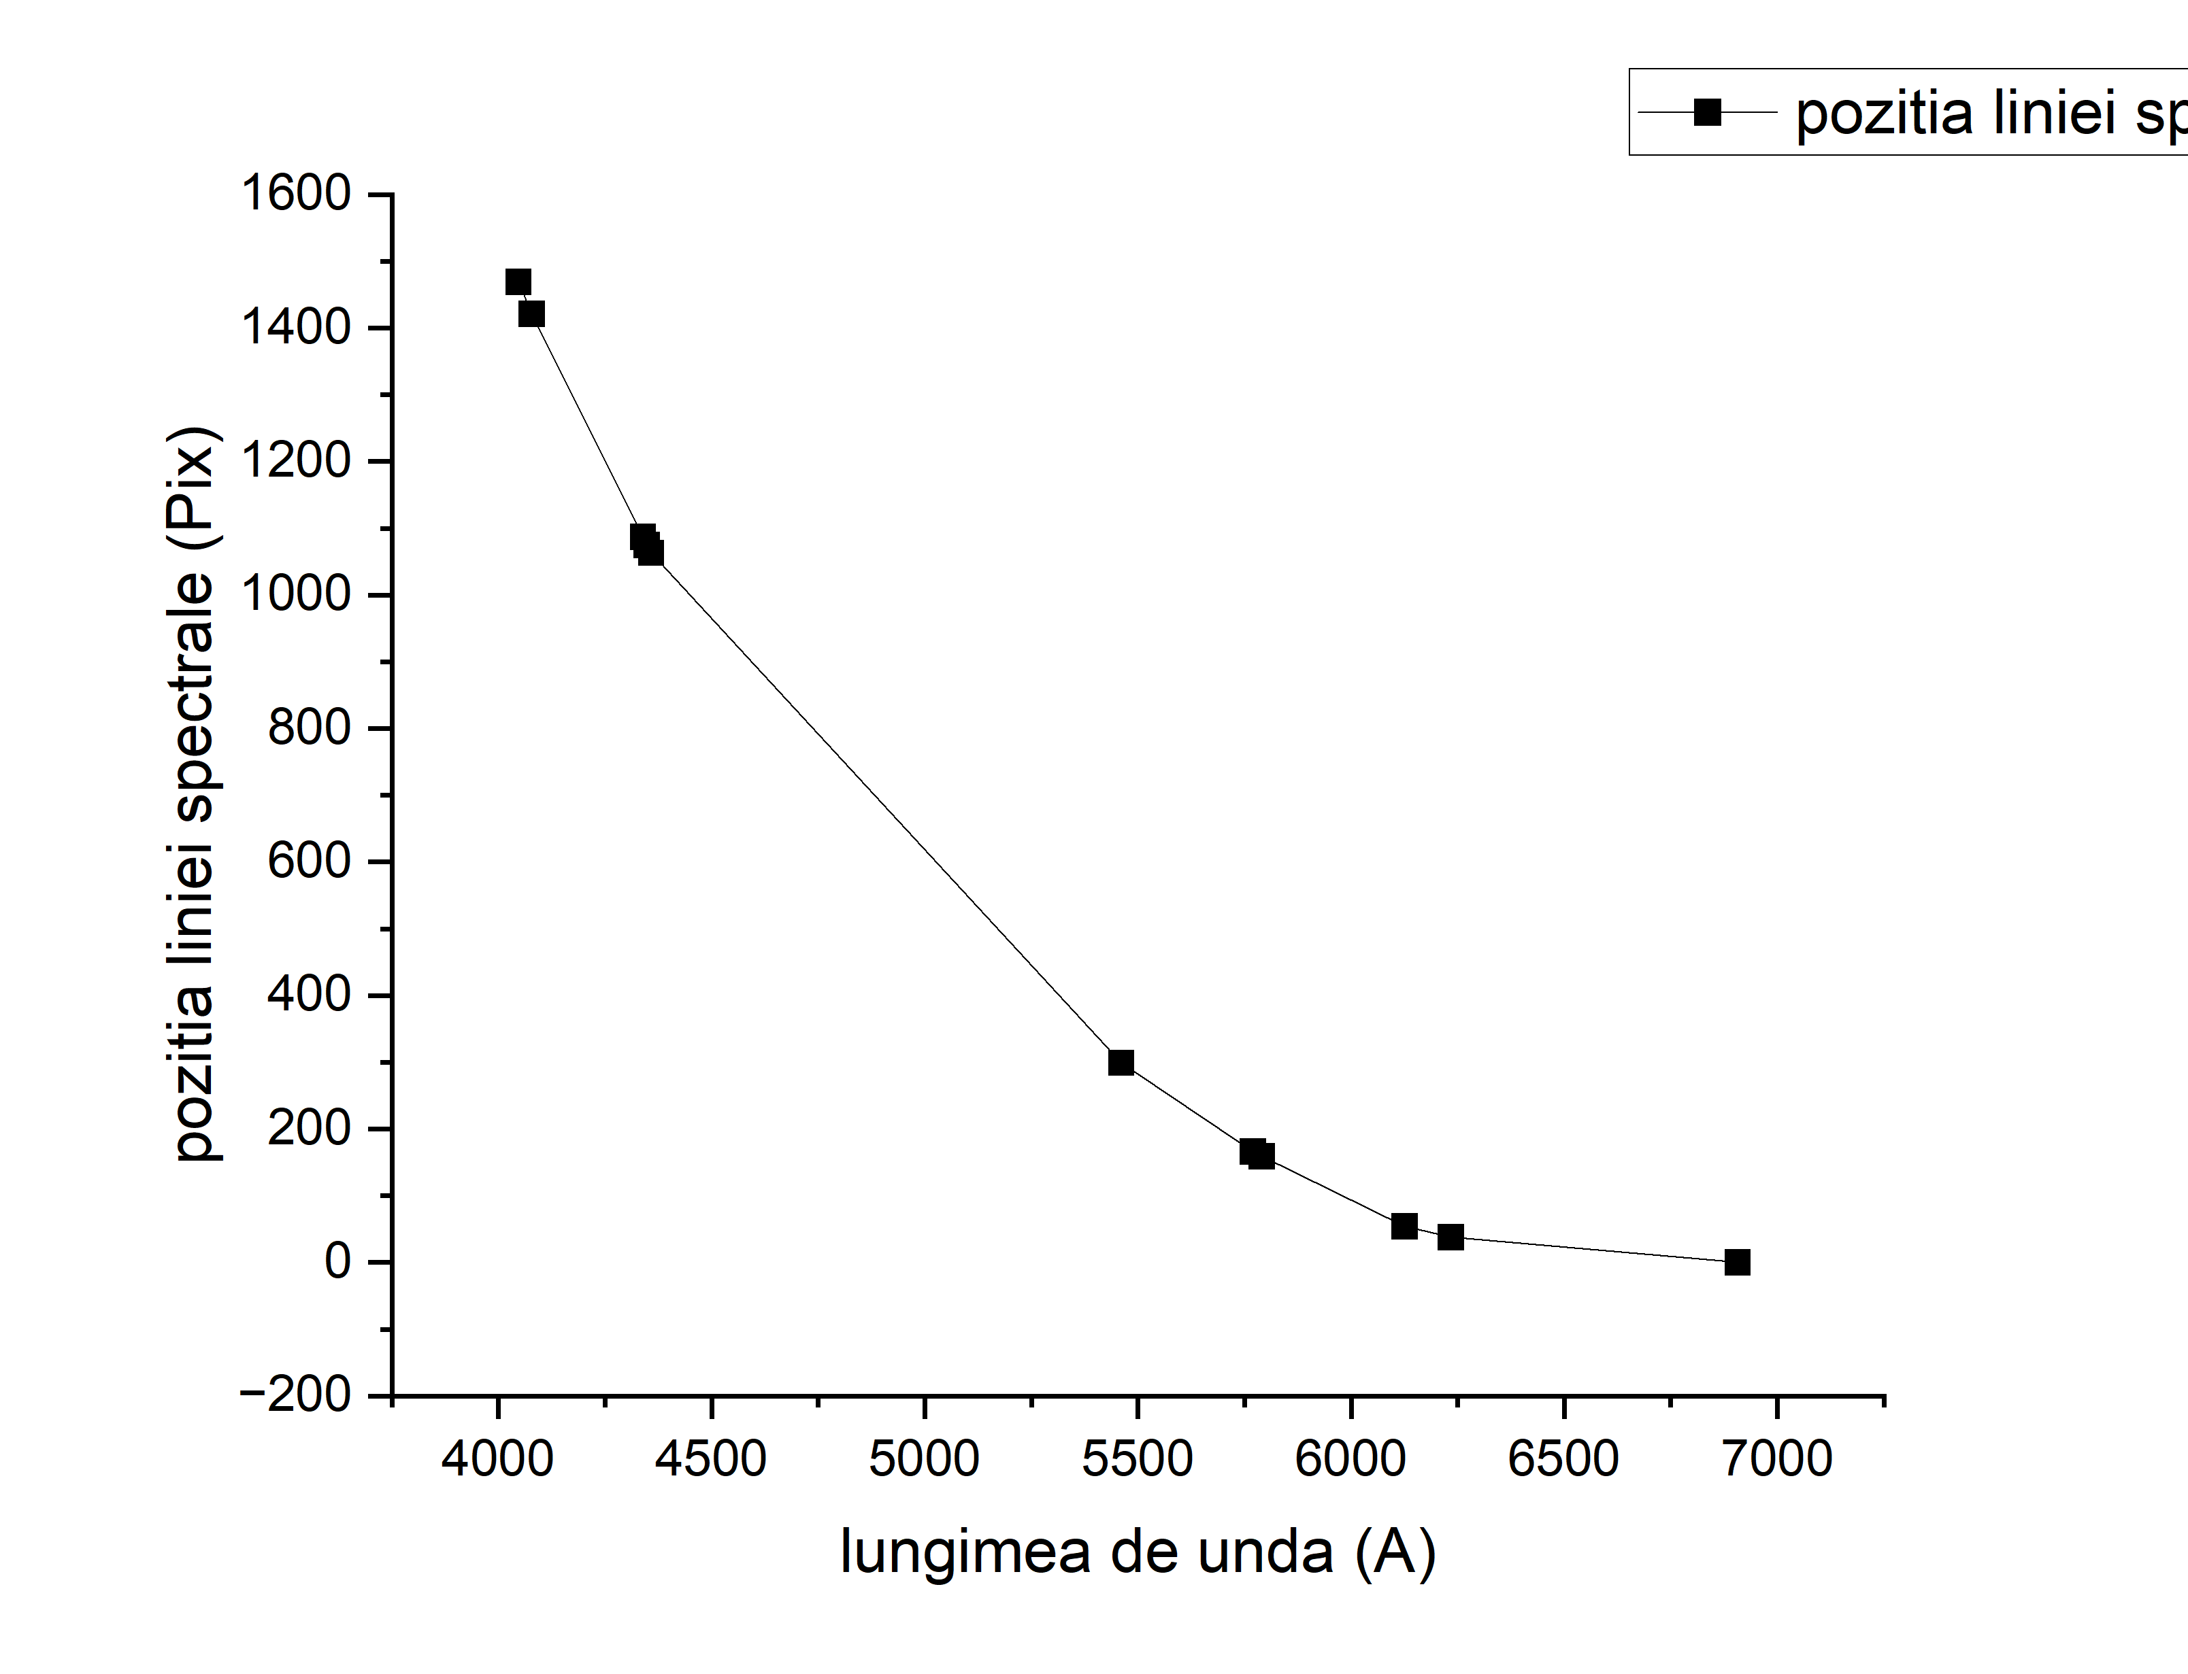

|  |  |  |  |  |
| --- | --- | --- | --- | --- |
| Lungimea de unda | Pozitia liniei spectrale | Lambda | Dispersia | Lambda mijloc |
| 6907.16 | 0 | 672.79 | 0 | 6570.765 |
| 6234.37 | 38 | 109.12 | 0.348240469 | 6179.81 |
| 6125.25 | 54 | 334.6 | 0.16138673 | 5957.95 |
| 5790.65 | 159 | 21.06 | 7.54985755 | 5780.12 |
| 5769.59 | 166 | 308.85 | 0.53747774 | 5615.165 |
| 5460.74 | 299 | 1102.39 | 0.271228875 | 4909.545 |
| 4358.35 | 1063 | 10.85 | 97.97235023 | 4352.925 |
| 4347.5 | 1075 | 8.26 | 130.1452785 | 4343.37 |
| 4339.24 | 1087 | 261.43 | 4.157900776 | 4208.525 |
| 4077.81 | 1421 | 31.25 | 45.472 | 4062.185 |
| 4046.56 | 1469 | 31.25 | 47.008 | 2023.28 |

